SQL Server User Mapping Error

When you restore a database onto another server and try to map a user, you may get an error that the user already exists.

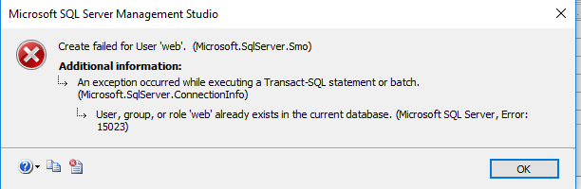

This can be fixed with the following query

<https://stackoverflow.com/questions/40256032/sql-server-user-mapping-error-15023>

USE DW_REPORTS

EXEC sp_change_users_login 'Auto_Fix', 'web'